Documentation: Catchment area maps from patient admissions records

Using Python, Excel, GMaps and Bing APIs, and qGIS

*Weber Liu*

*University of Sydney*

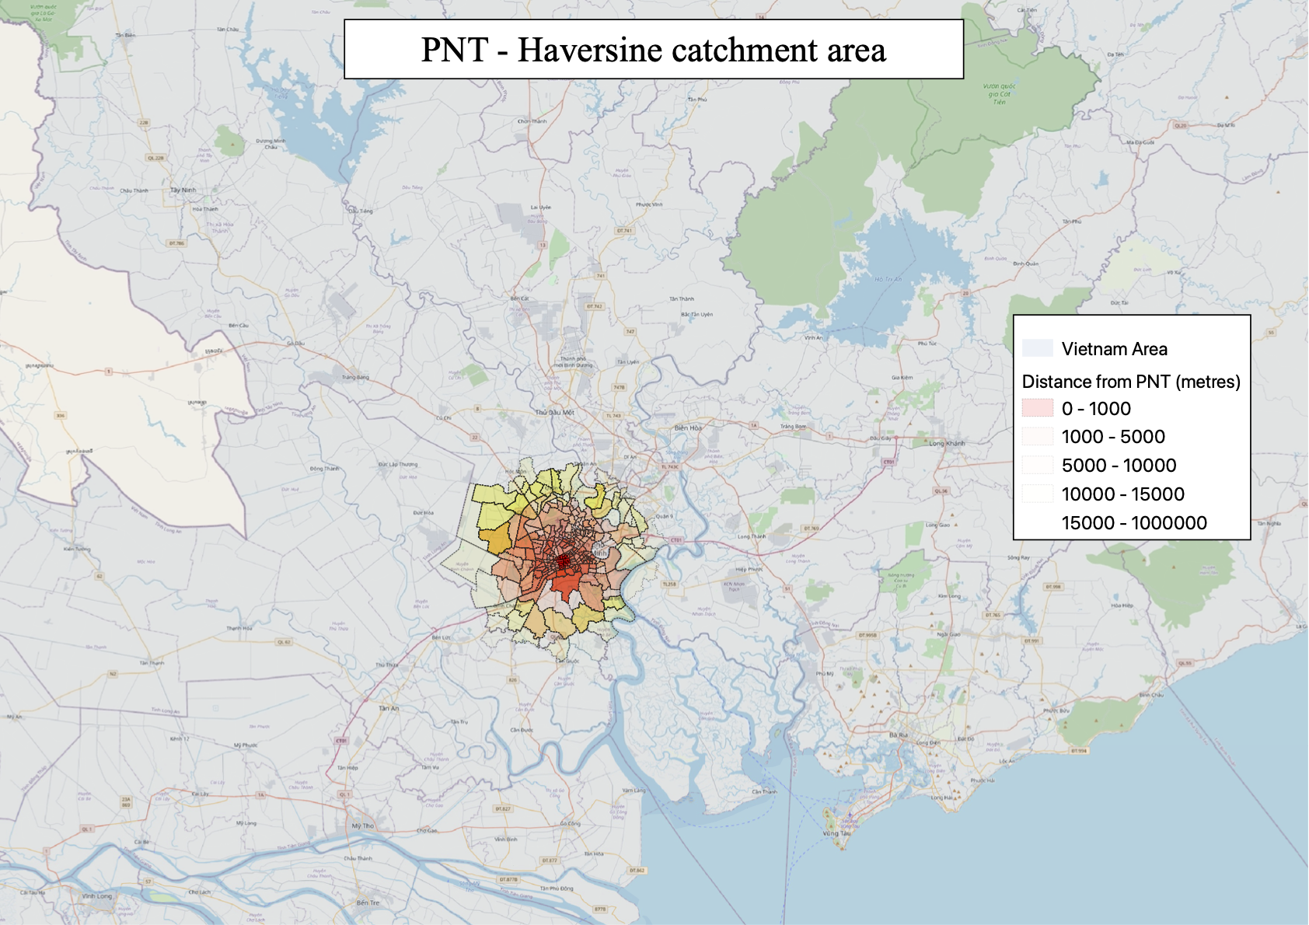

Table of Contents

Part 1: Loading map into qGIS 2

Part 2: Generating data 4

Part 2a: Geocoding 4

Part 2b: Distance matrix 4

Part 2c: Straight line distance calculation 4

Part 2d: Patient flow calculation 4

Part 3: Loading latitude and longitude data 5

COUNTING POINTS IN POLYGONS 6

Approach to displacement modelling 8

Approach to Patient-flow modelling 12

Section X: Basemaps and outlines 14

Section X: Exporting maps 17

# Part 1: Loading map into qGIS

1. Download the latest Vietnam Geopackage from the GADM website: <https://gadm.org/download_country_v3.html>
2. Open qGIS and open a new project file

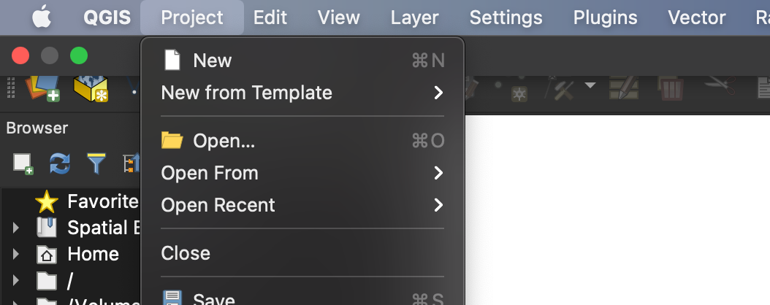

1. Open the Data Source Manager

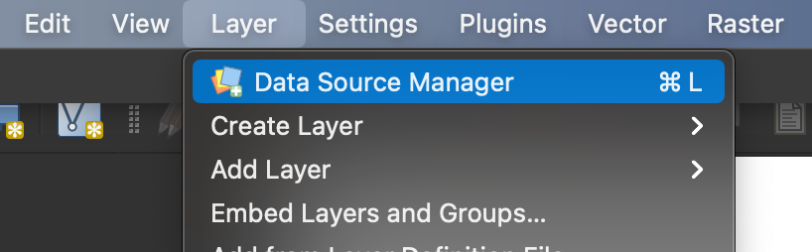

1. Add the geopackage downloaded from step 1 and include gadm36_VNM_3 (multipolygon geometries at the ward level)

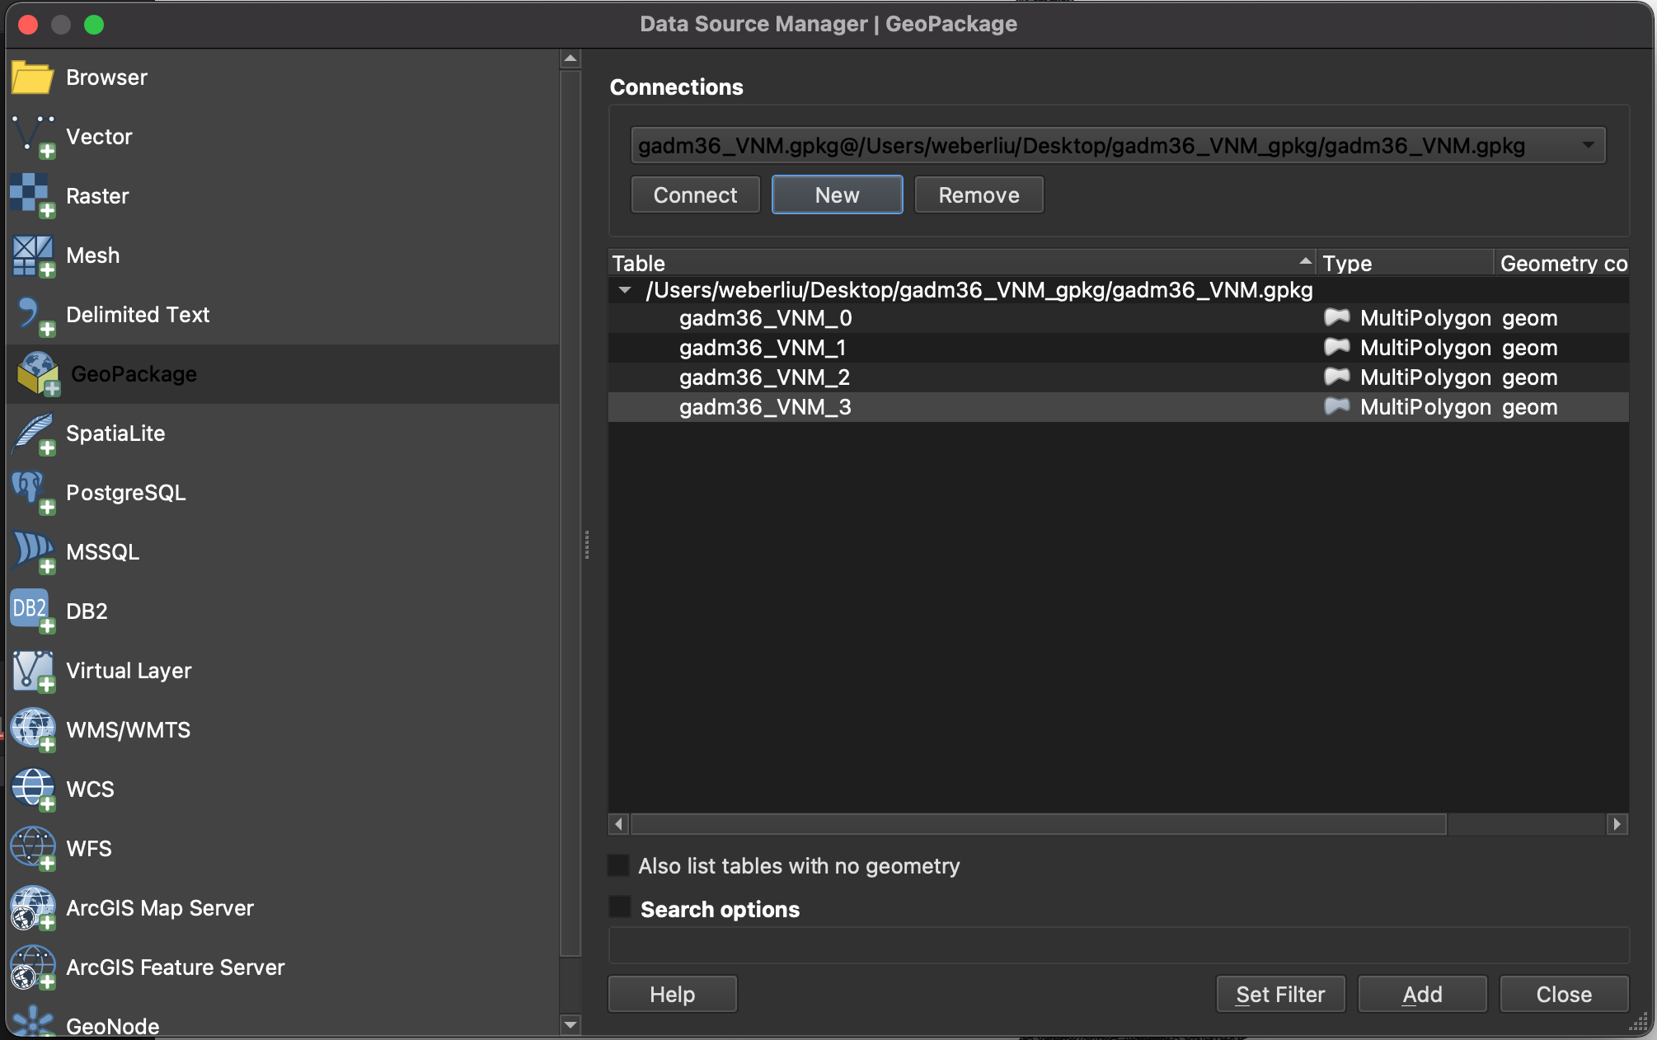

1. A map of Vietnam should now be loaded

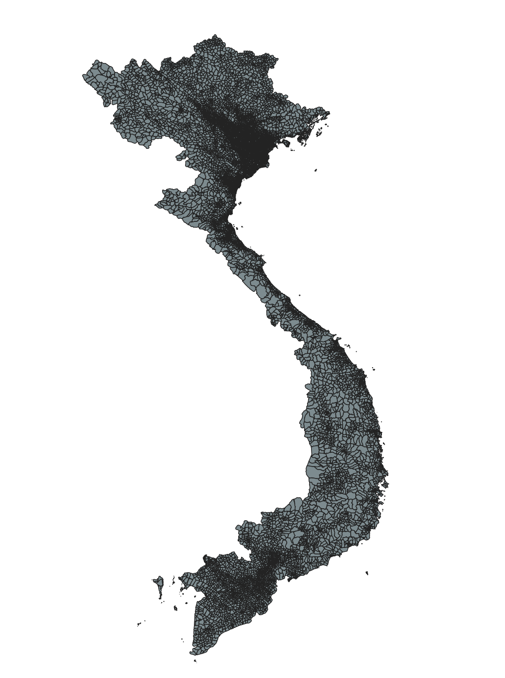

# Part 2: Generating data

## Part 2a: Geocoding

## Part 2b: Distance matrix

## Part 2c: Straight line distance calculation

## Part 2d: Patient flow calculation

# Part 3: Loading latitude and longitude data

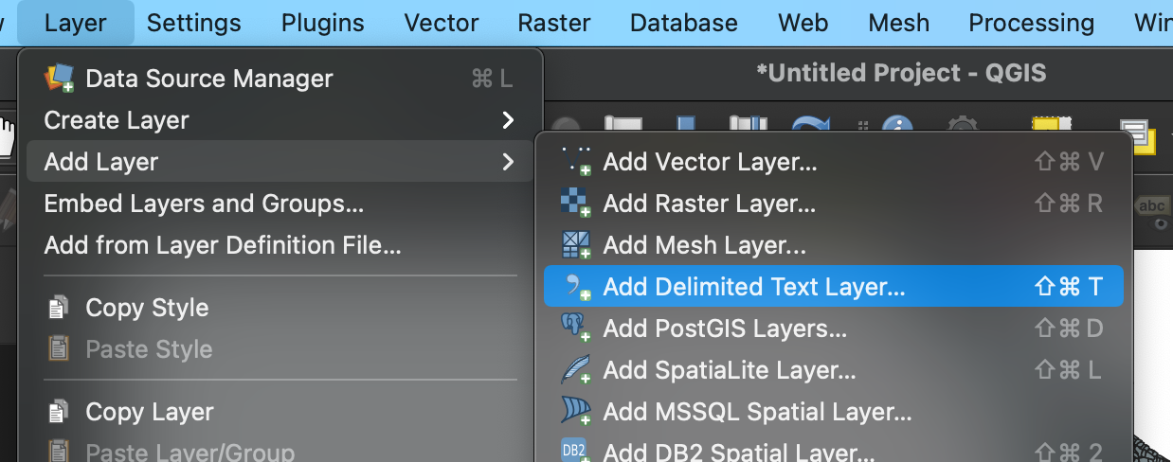

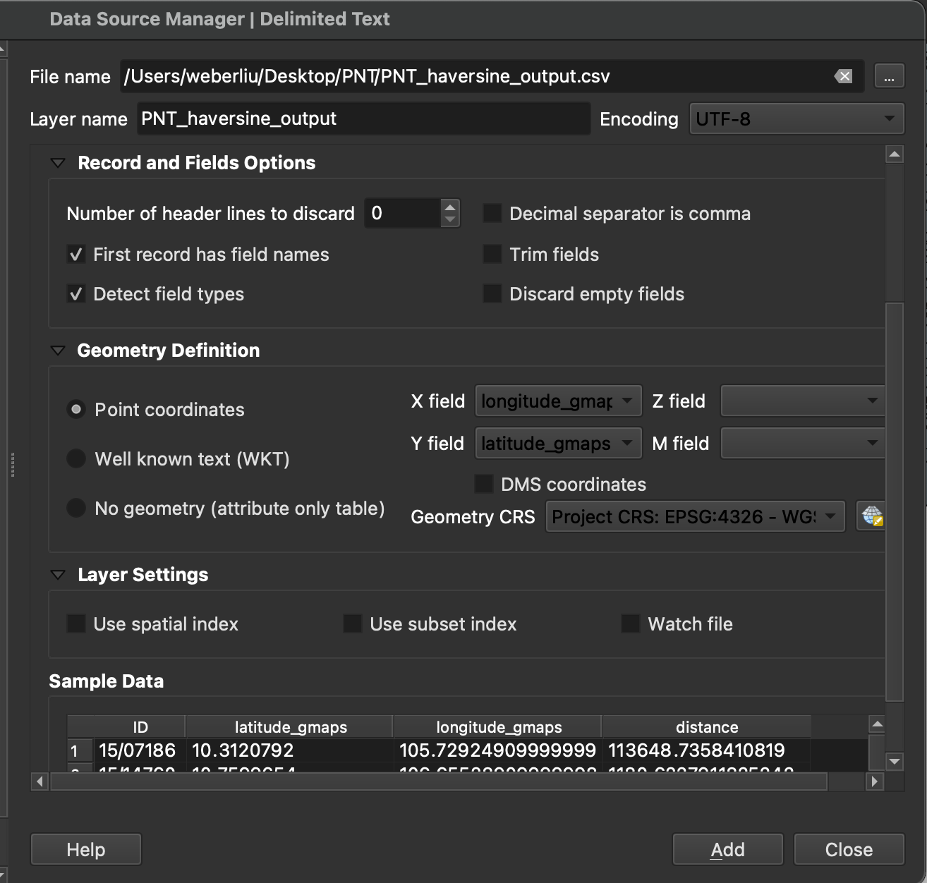

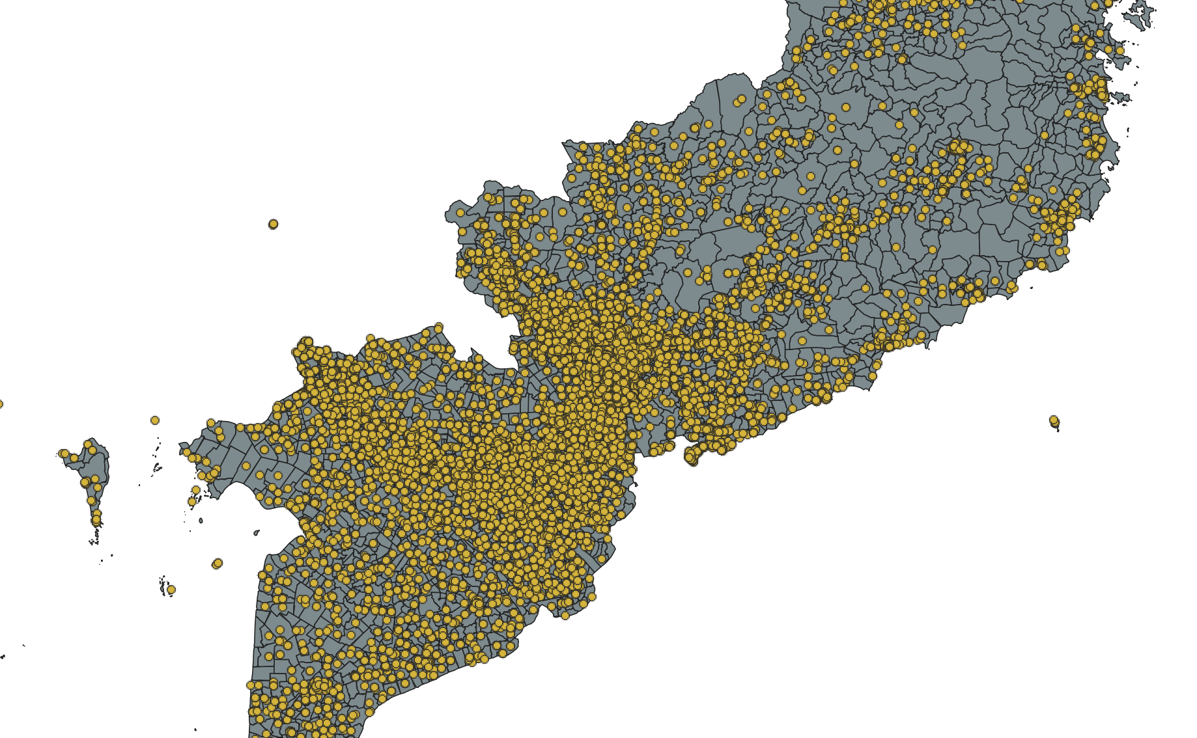

# COUNTING POINTS IN POLYGONS

1. Load the shape data (GADM dataset)
2. Load in ANY csv file with the patient address data (Original geocoded data, Haversine dataset and distanceMatrix dataset will all contain patient address data as by design of the Python scripts developed)
3. Vector -> Analysis tools -> Count points in polygon

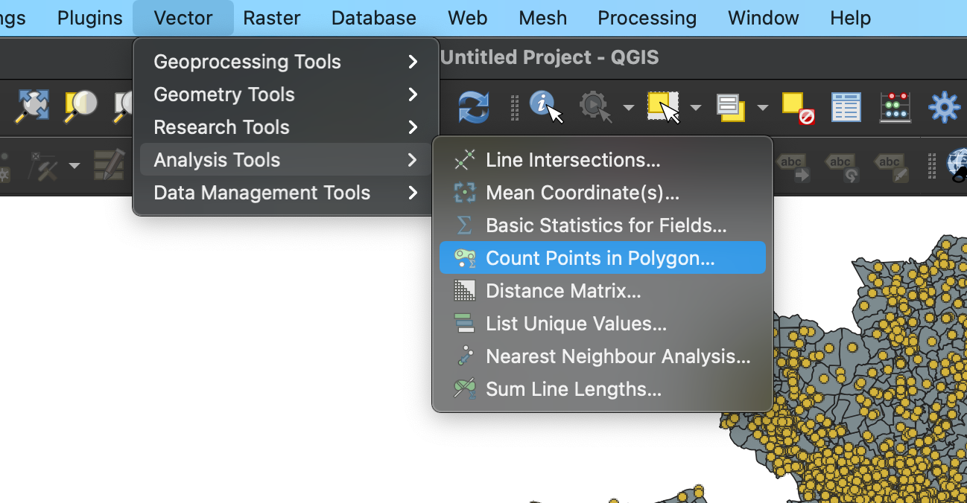

1. Use the following settings, where Polygons and Points are chosen appropriately. This data will later be exported once this function has been run.

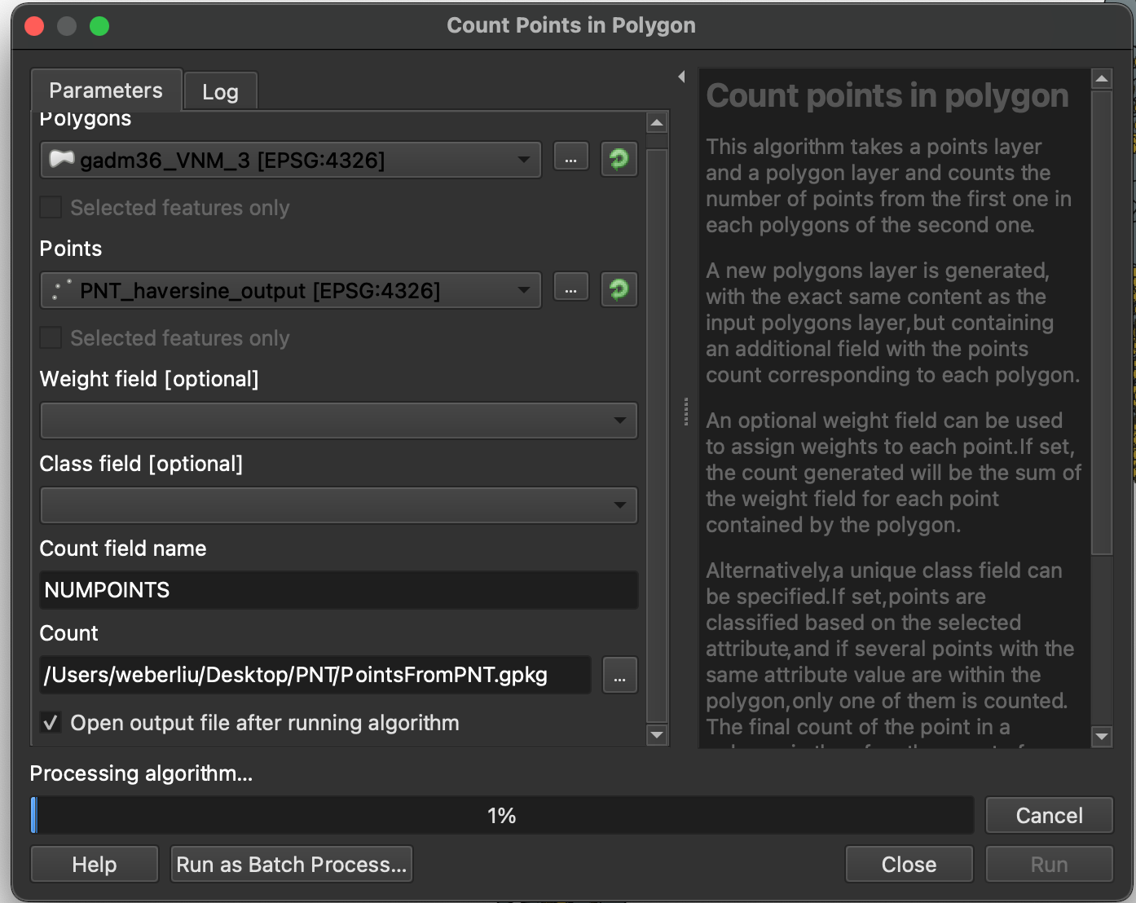

Settings for counting points in polygons

# Approach to displacement modelling

1. Load the Haversine-output data into qGIS, making sure that the dataset is loaded as csv and points have been added (as in section X)
2. Perform a spatial join with the Haversine output data and the geometry

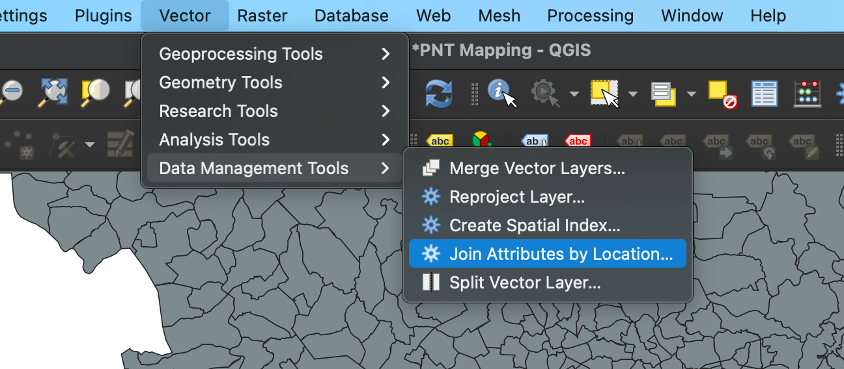

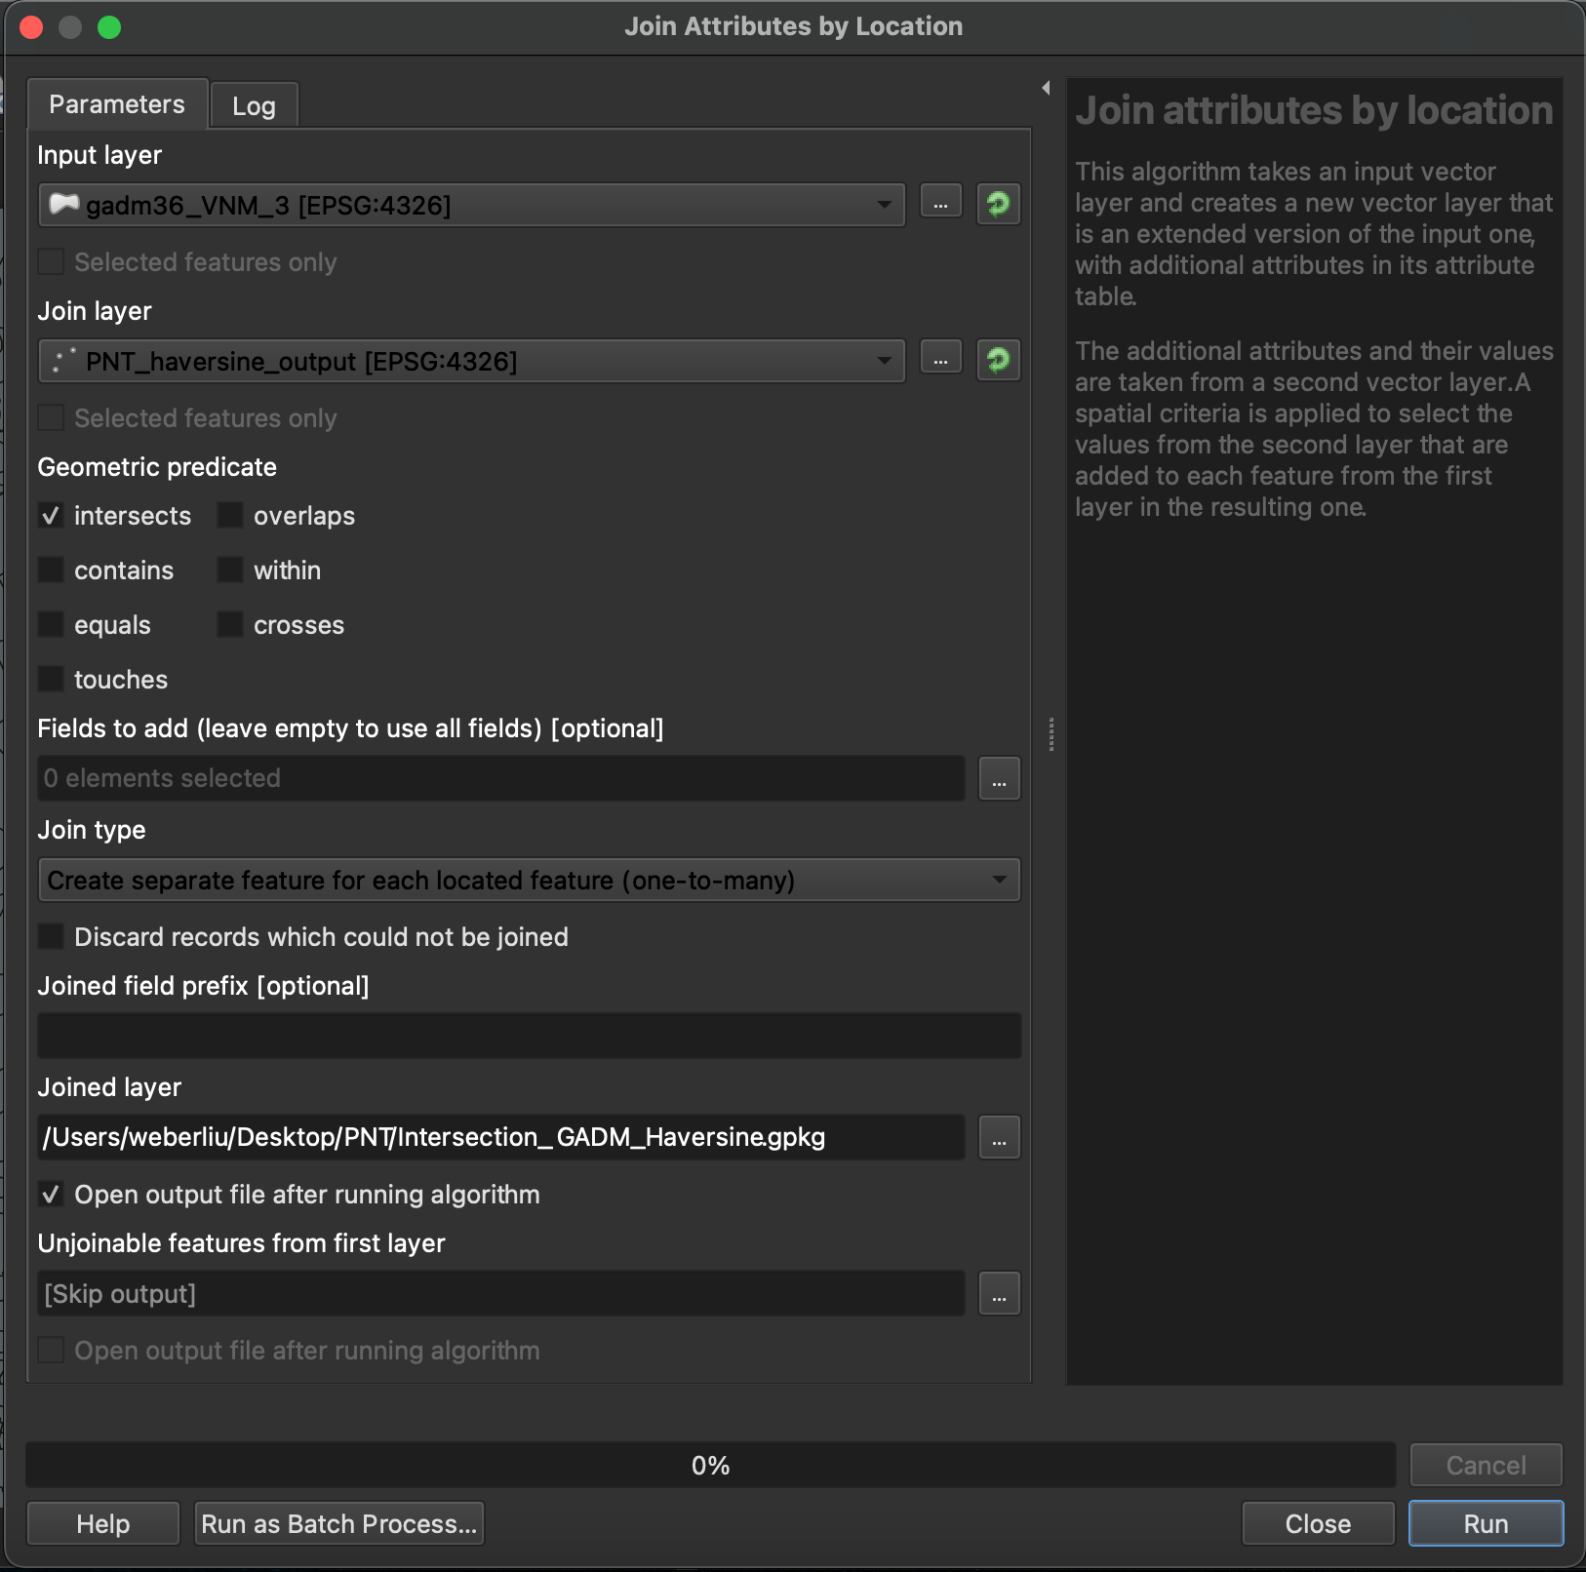

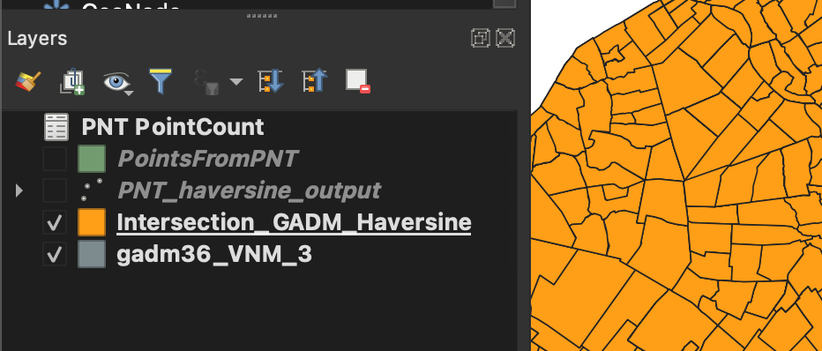

A new layer would have been created

1. Right click the new geometric layer (as we will be changing the colours of the wards, which are defined on this layer) and click properties

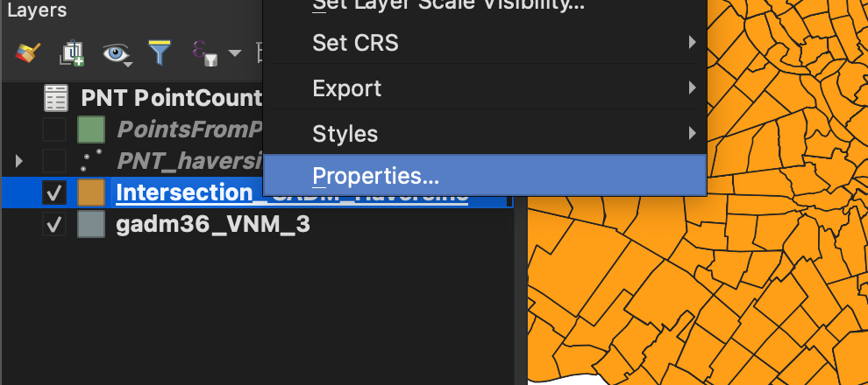

1. In the symbology section, change from ‘Single Symbol’ to ‘Graduated’

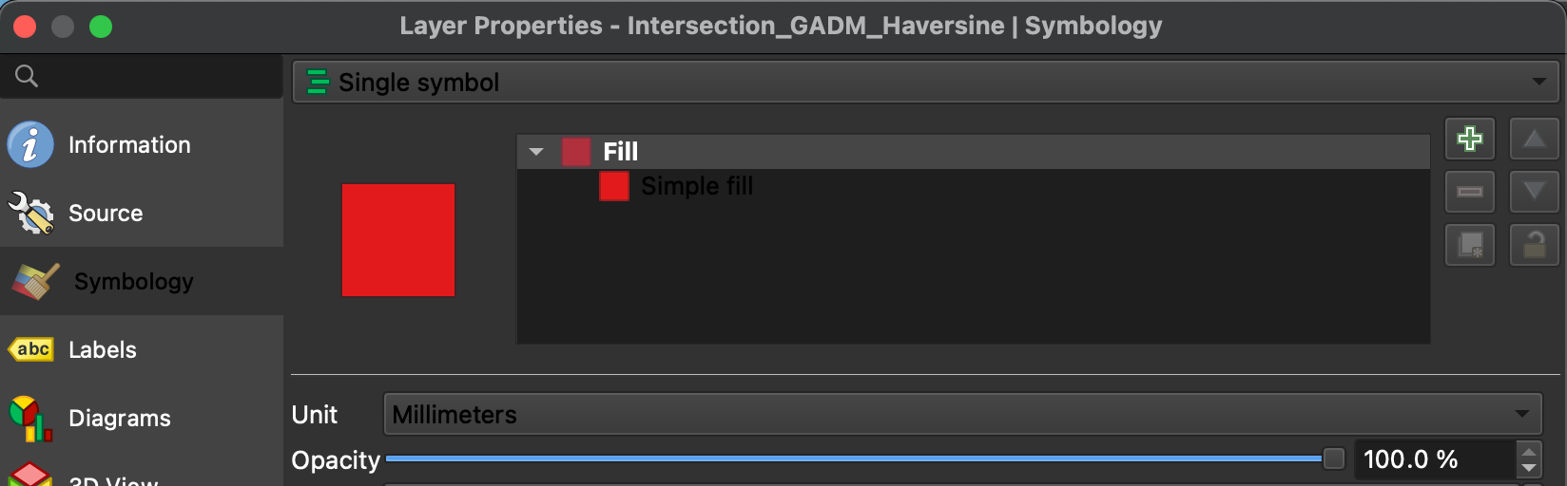

1. Select ‘distance’ as the value – this indicates that the colour will be based on the ‘distance’ value

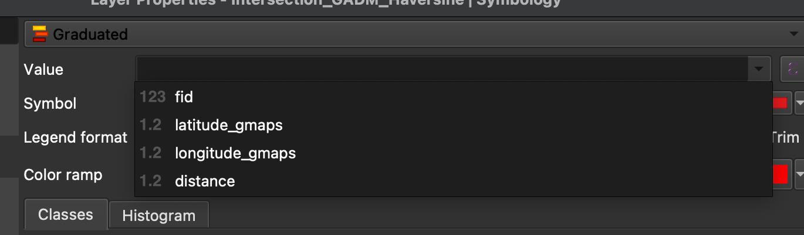

1. Add the number of classes desired (each class represents a different distance)

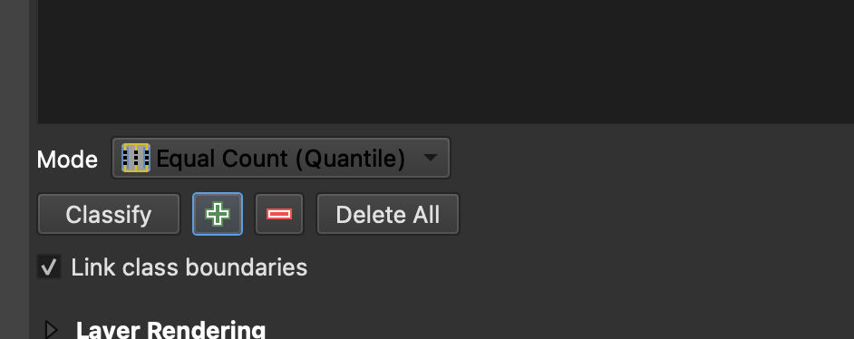

1. Create the preferred number of graduated intervals at preferred distances

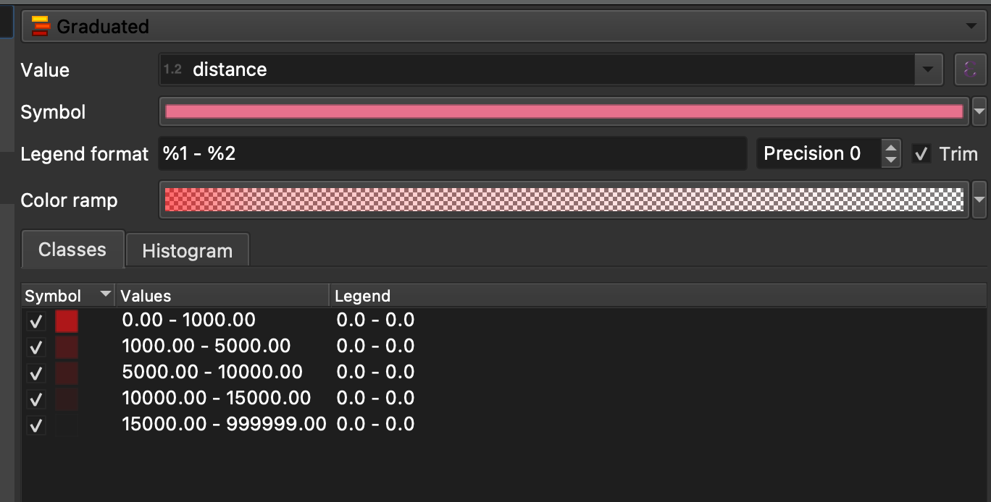

1. Preferrably change the colour ramp from some colour (e.g. red) to transparent

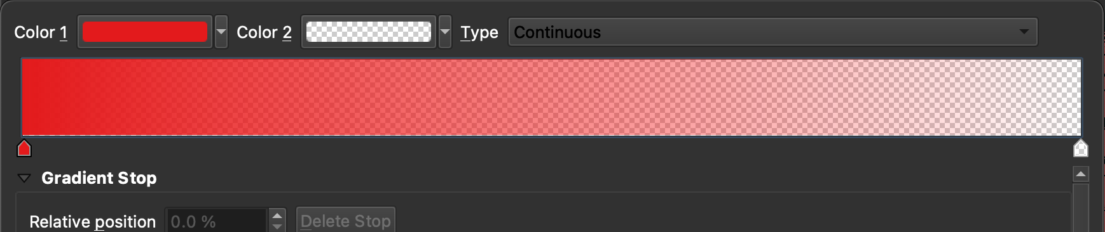

1. Currently, the map should look like the following

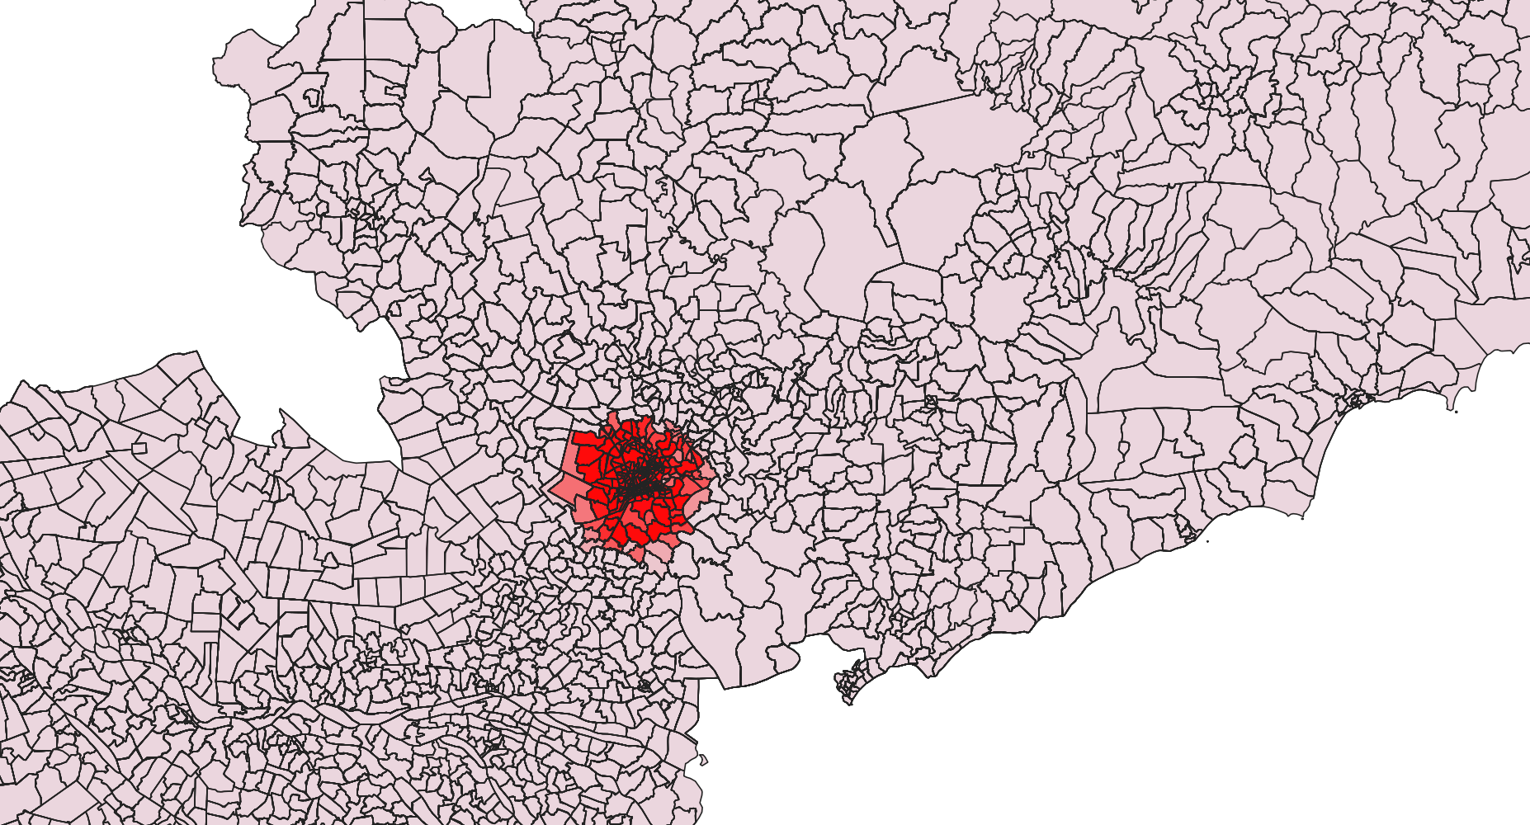

1. For additional aesthetic features to add to your map (e.g. street and satellite basemaps), see Section X: Basemaps and country outlines
2. For exporting maps see Section X: Basemaps and printing

# Approach to distance matrix modelling

## Travel Distance

1. Load distance matrix data as you would load haversine data

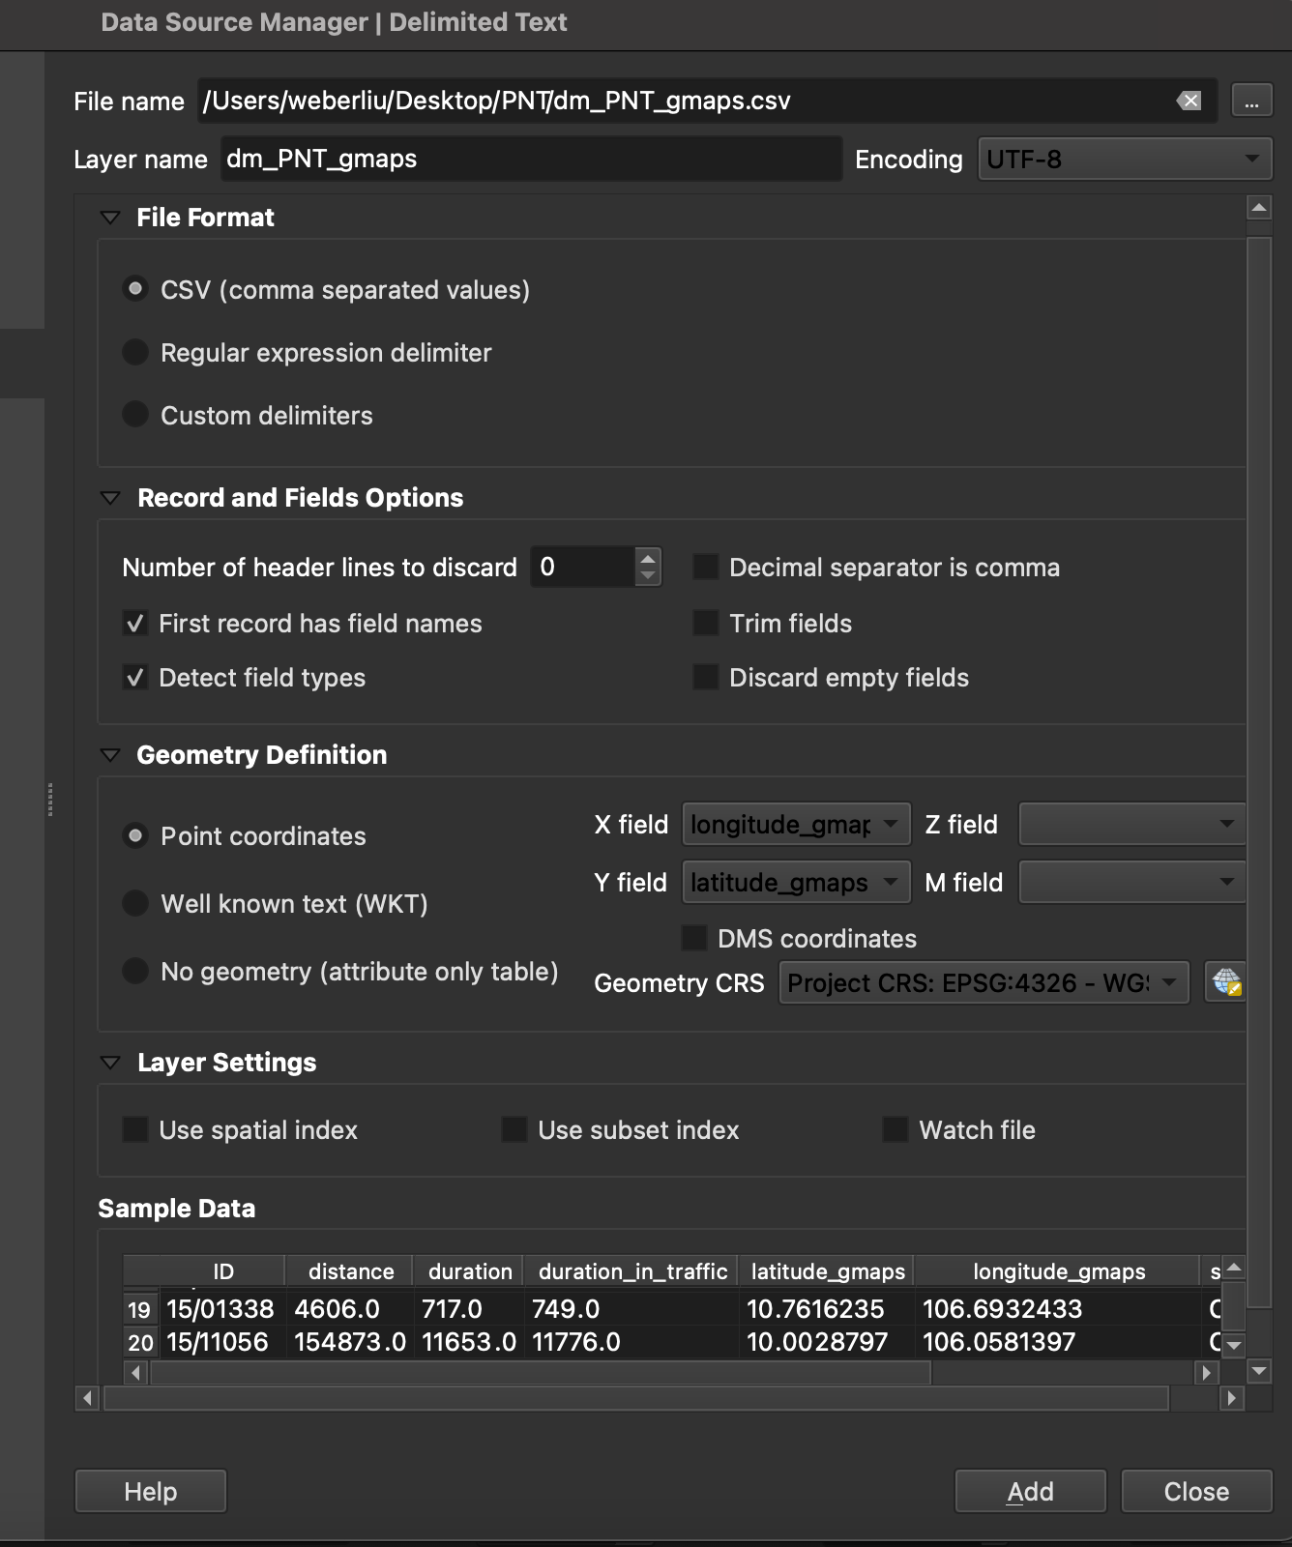

1. Ensure that the ShapeFiles are also loaded
2. Join attributes by location – shapefile on Input layer and the PNT DistanceMatrix values on the Join layer

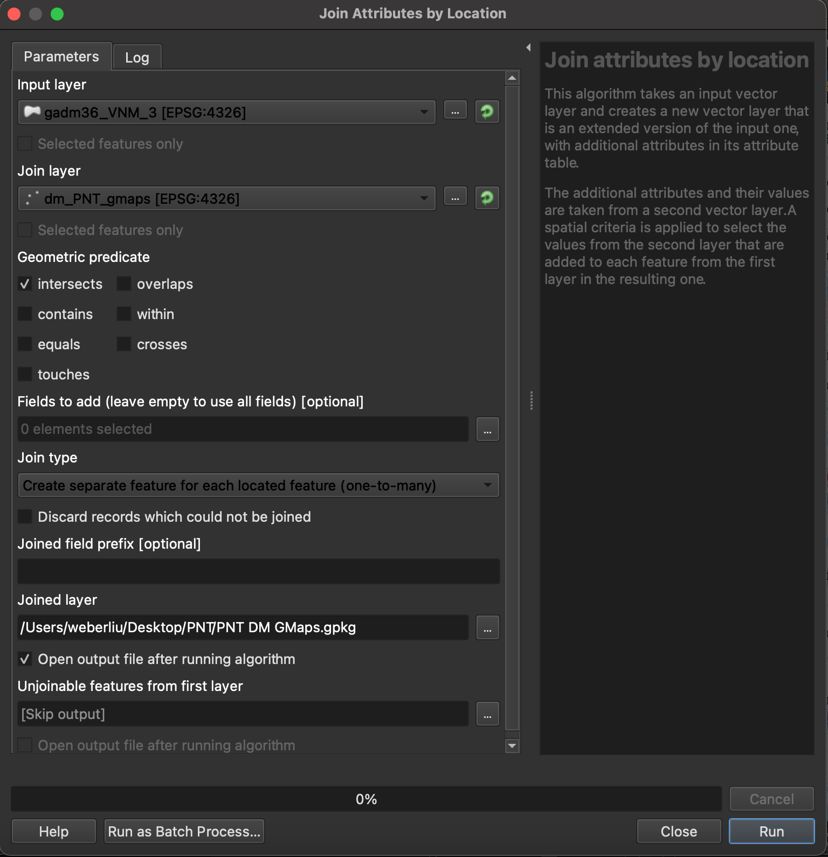

1. A new layer would have been created

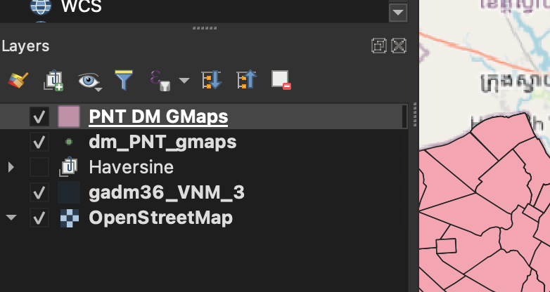

1. Open properties for the new layer

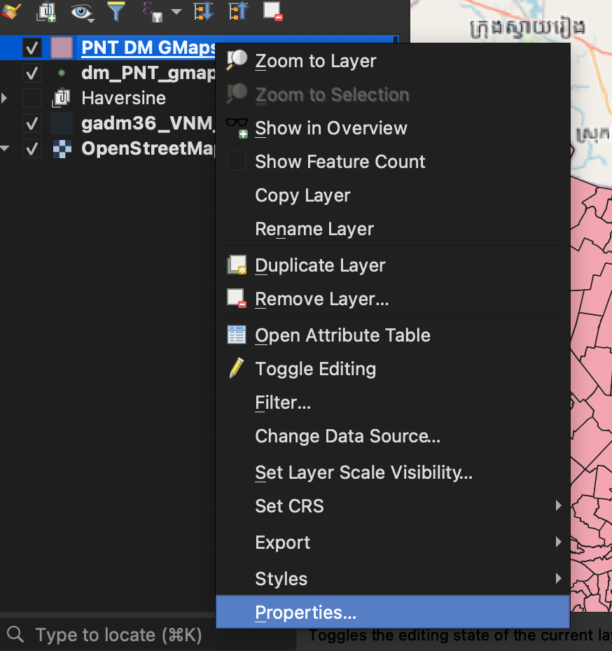

1. Symbology -> Change from ‘Single symbol’ to ‘Graduated’
2. Set the Value based on ‘Distance’

## Travel Duration

1. To use the travel time data in the distanceMatrix dataset, in the Layer properties section, select ‘duration’ as the Value rather than ‘distance’

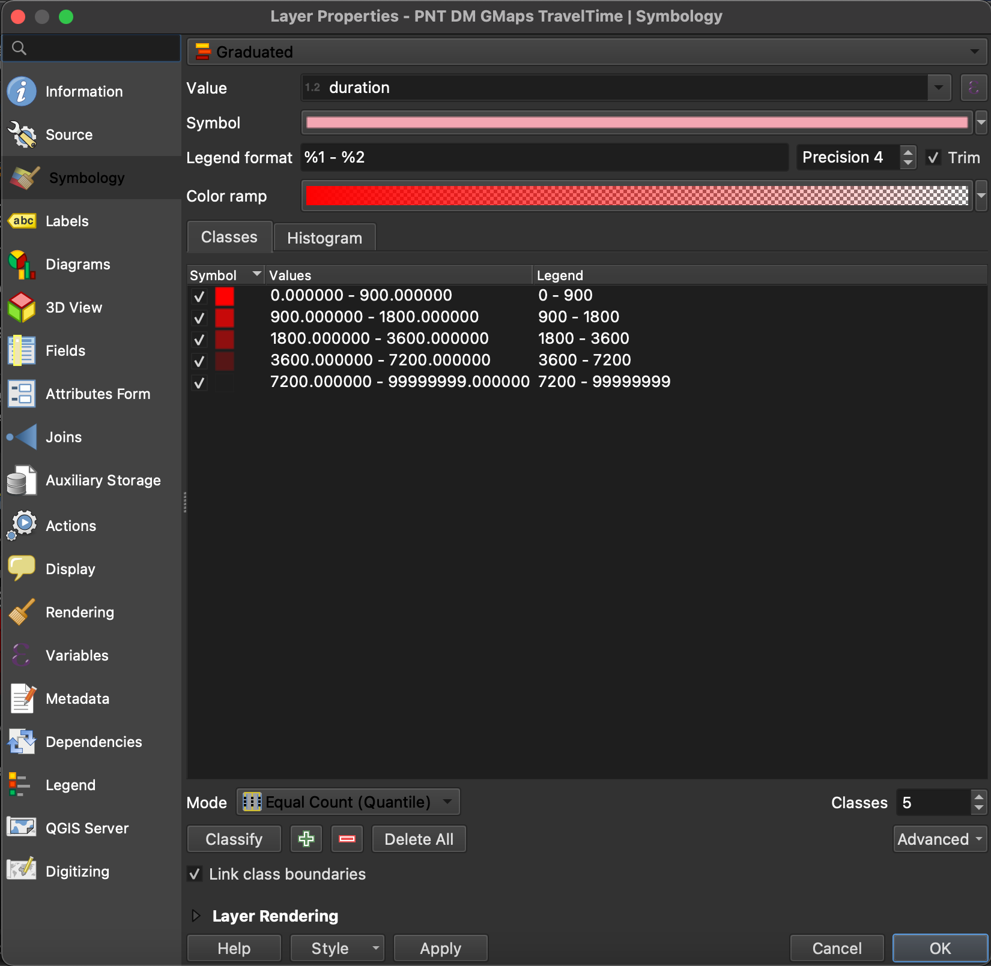

# Approach to Patient-flow modelling

General concept

1. After finding the pointcount within the polygon, save this data
2. This can be done by

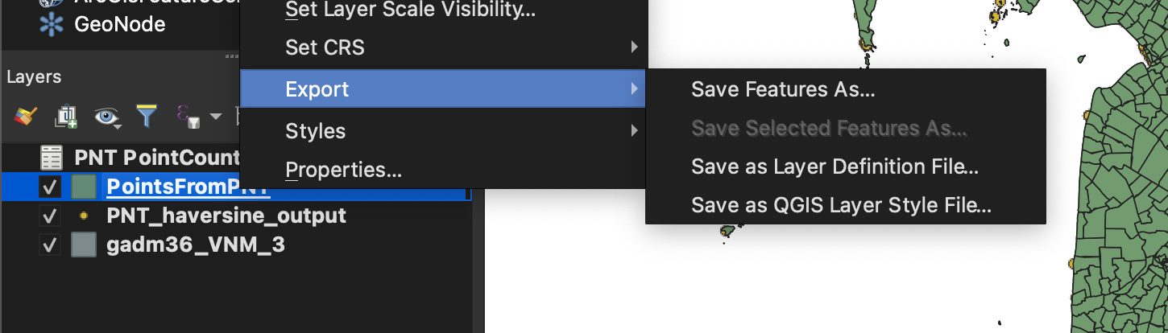

1. Include only variables GID_3, NAME_3, VARNAME_3 (for identification of the geometry) and NUMPOINTS (the variable indicating number of points in each variable)
2. Use the following settings when saving
3. Install the worldPop plugin: <https://github.com/wpgp/wpgpDataQPD>
4. Download the population data for Vietnam in 2015 via WorldPop

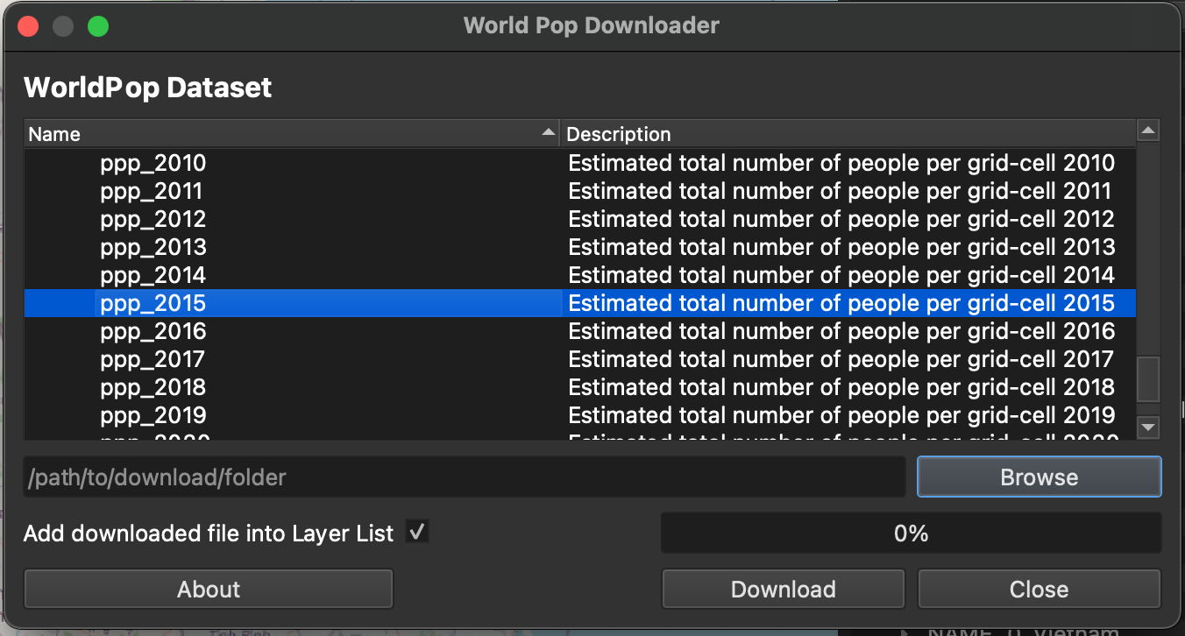

Once the raster files have been added, they will present as a black mask over the area – the pixel value of each point on the raster indicates a population value for that location. 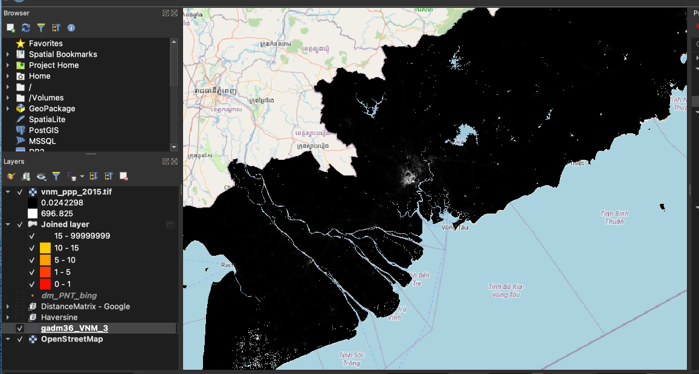

1. Determine the statistics per ward from the raster data
   1. Processing (menu) -> Toolbox
   2. Look for ‘Zonal statistics’ tool
   3. Use the following settings – include statistics of Sum, Mean and standard deviation (others can be included if desired)

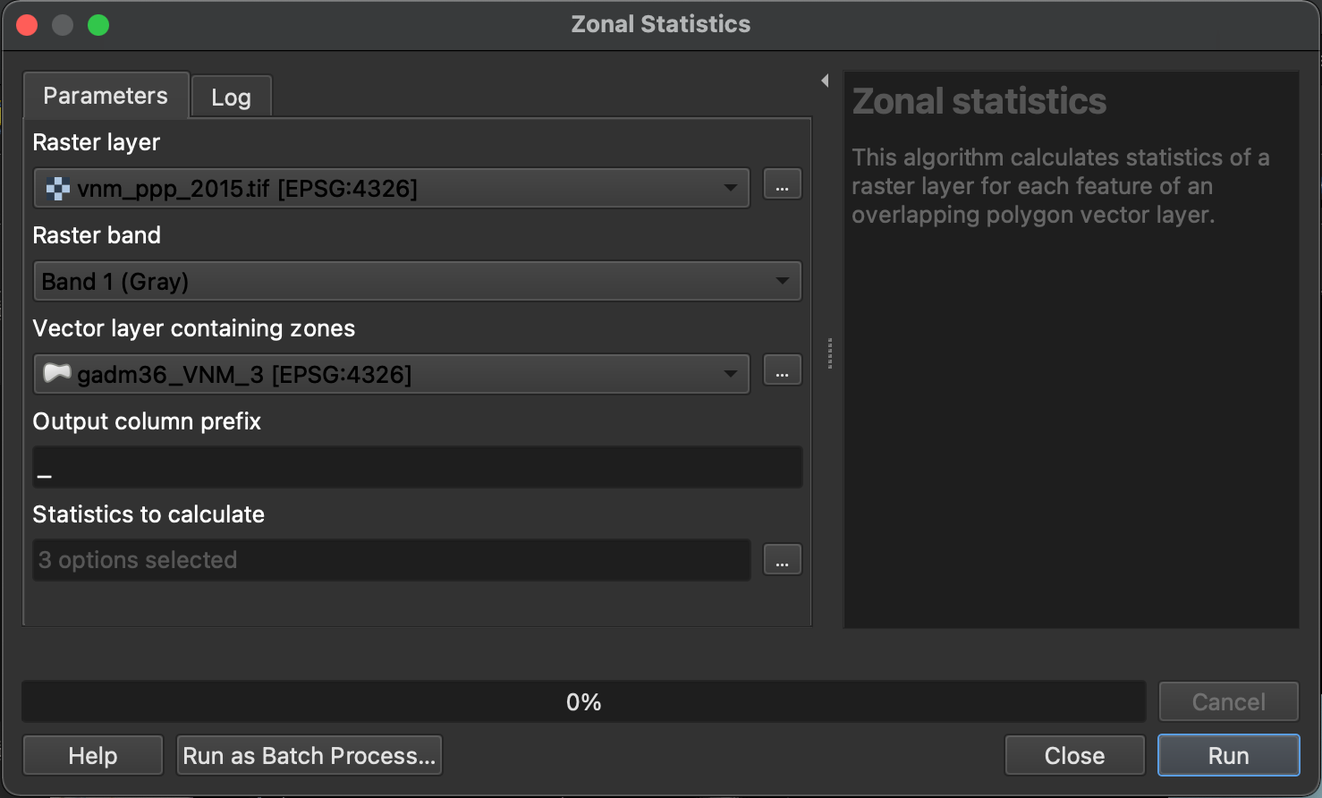

The outcome will be saved in the vector layer

1. Extract the data from zonal statistics from the vector layer
   1. Right click -> Save features as
   2. Save with the following options – You will not need to save the geometry

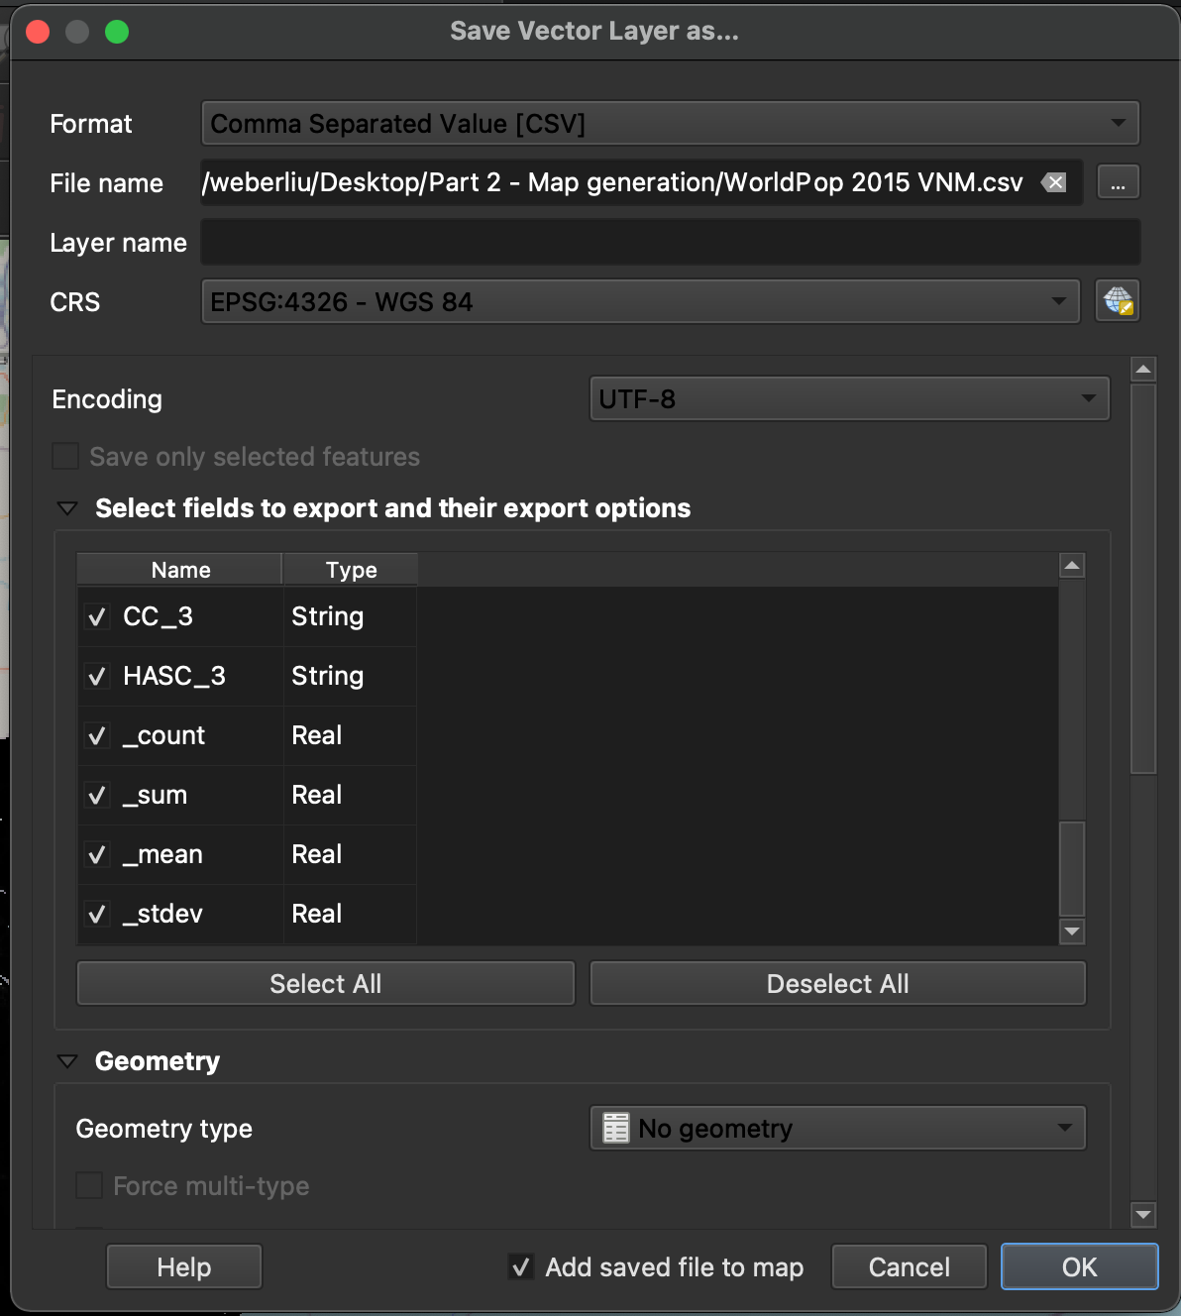

1. Calculate 95% upper CI of count data and estimated cases given case ratio from the extracted data (Excel, R)
2. From data, if 95% CI > expected data, include data in catchment area. Give these a prefix of ‘1’ in another column, save as CSV file and import as csv into qGIS
3. Add delimited text layer in qGIS

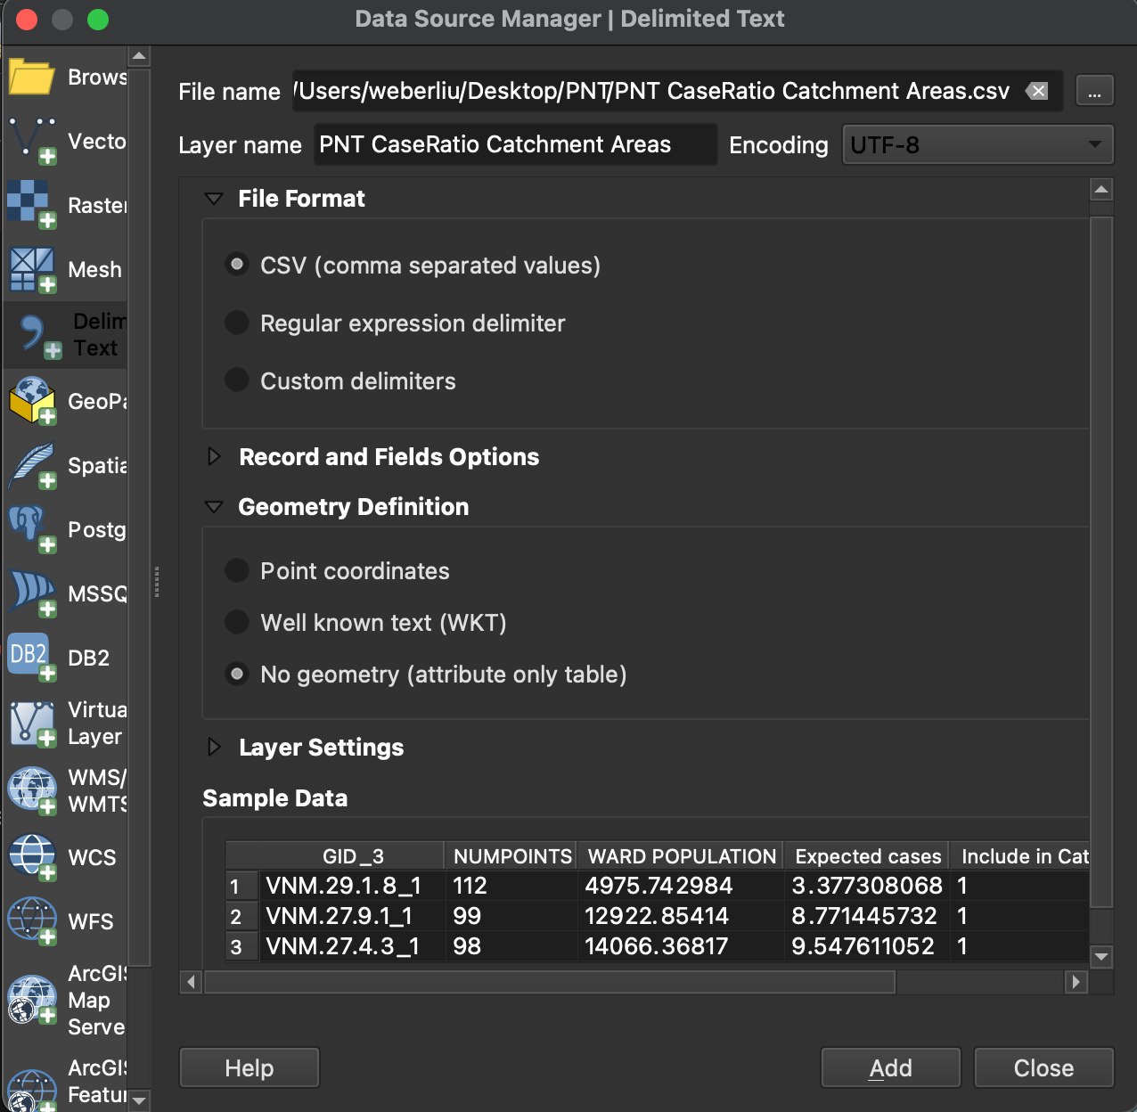

1. Join attributes by shared variable GID_3
2. Duplicate the GADM layer (right click -> duplicate) and rename (e.g. “Case ratio catchment area”)

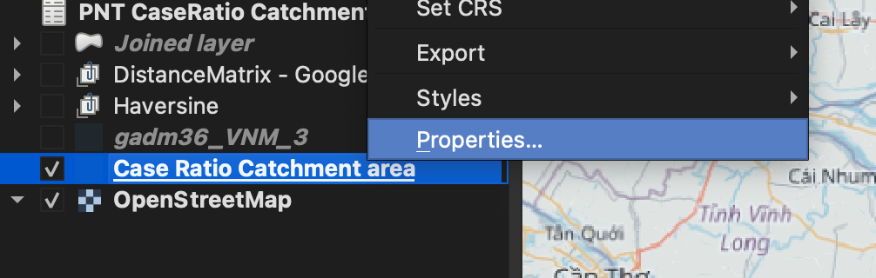

1. Joins layers by a shared attribute
   1. Processing -> Toolbox -> “Join attributes by field value”

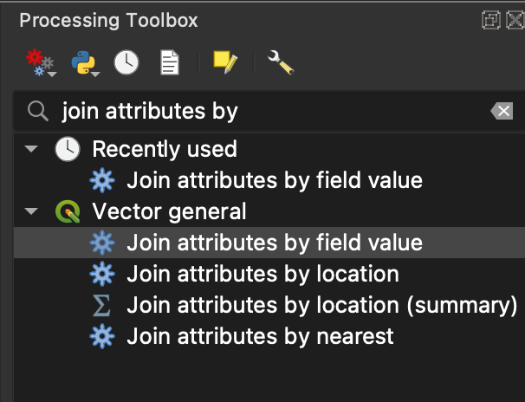

1. Use the following settings

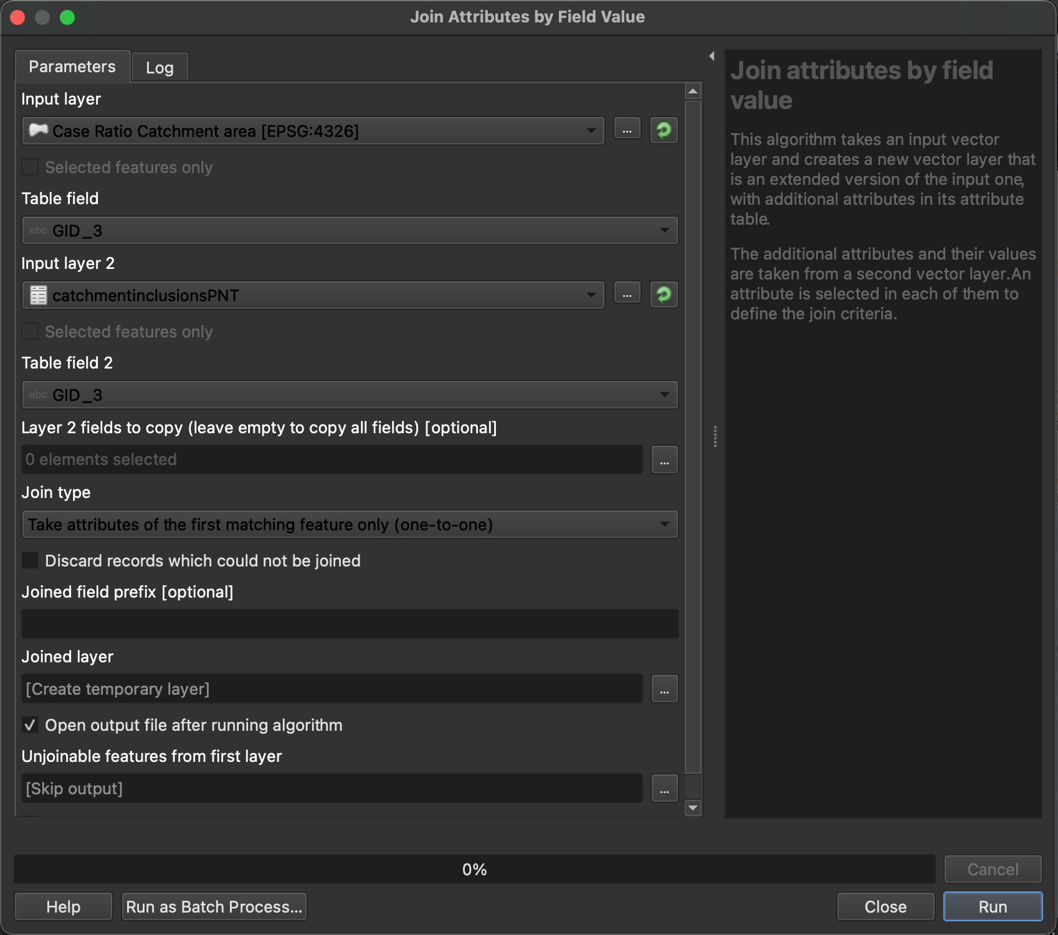

1. Will create a new shape layer, rename it to ‘case ratio catchment area’
2. Right click -> properties -> symbology -> set value to ‘categorized’ -> click ‘classify’ -> will classify 3 separate values (0, 1, other) -> the value 1 indicates that the region is within the catchment area

Analysis of distanceMatrix and displacement of peoples by ward

1. Processing -> Toolbox -> “Statistics by categories”
2. Use the following options
   1. Input vector layer: The generated map (from earlier) through which you want to analyse – e.g. Haversine or DM maps
   2. Field to calculate statistics on: Distance or Duration (Distance to calculate the min distance patient living in ward to hospital, etc.)
   3. Field(s) with categories – categorise by GID_3 for Ward-level analysis

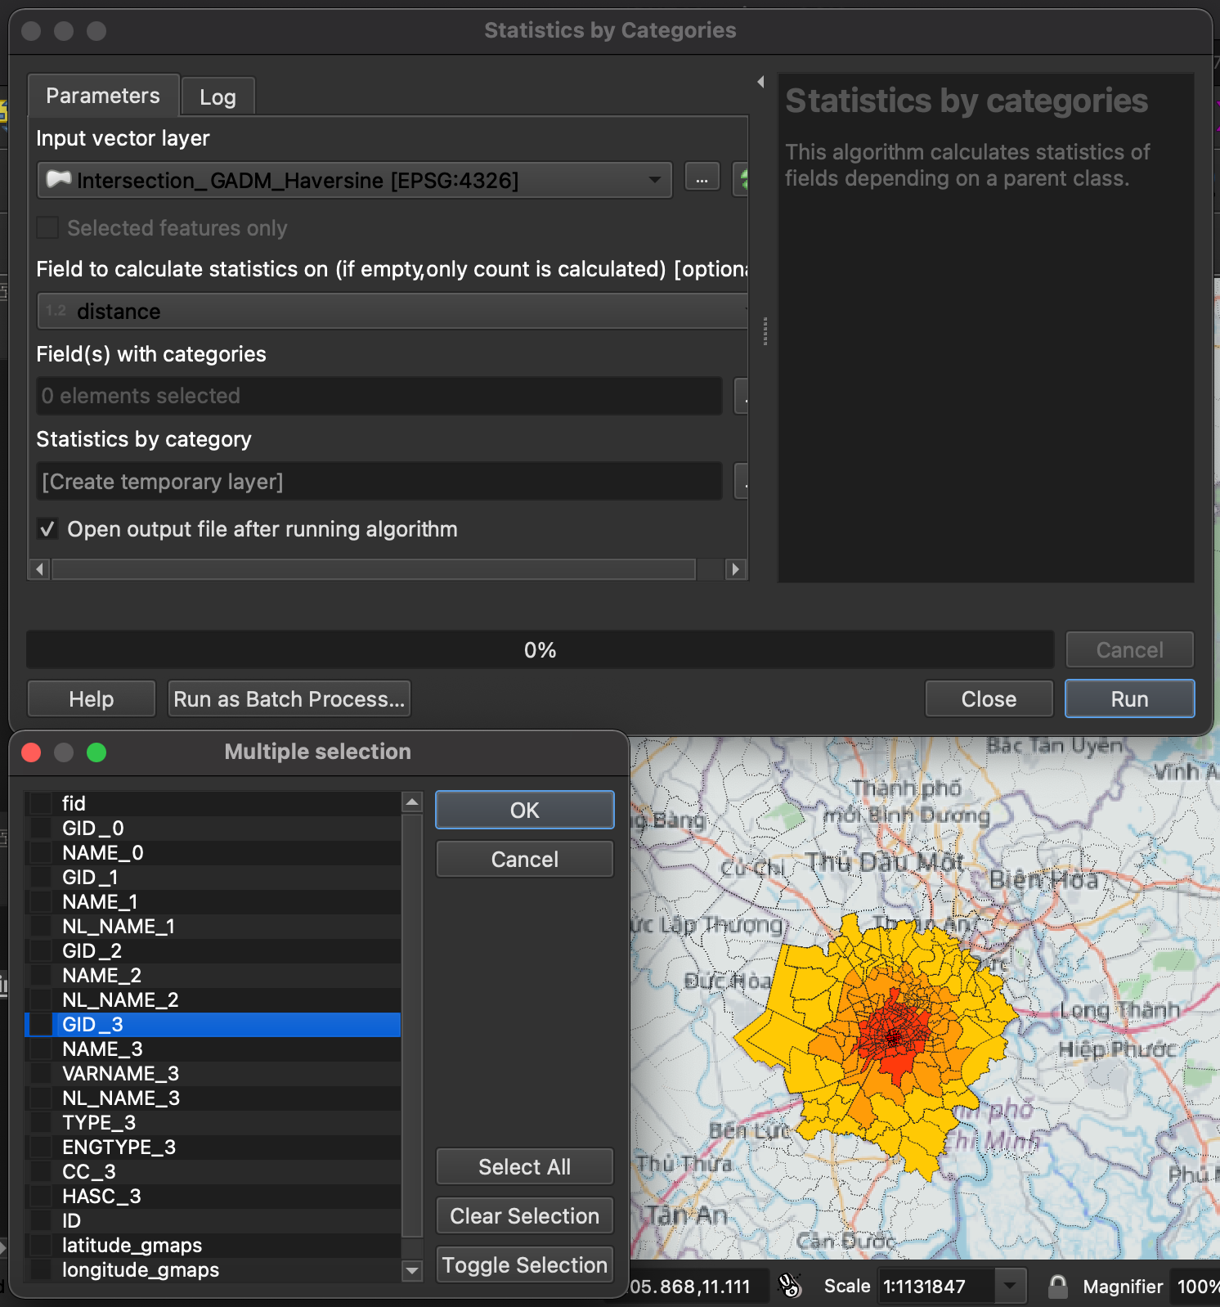

1. Export the generated attributes table

Uganda study used distances of 5, 10, 20, 30km for straight line distance

Average distance of VNM household from govt hospital. 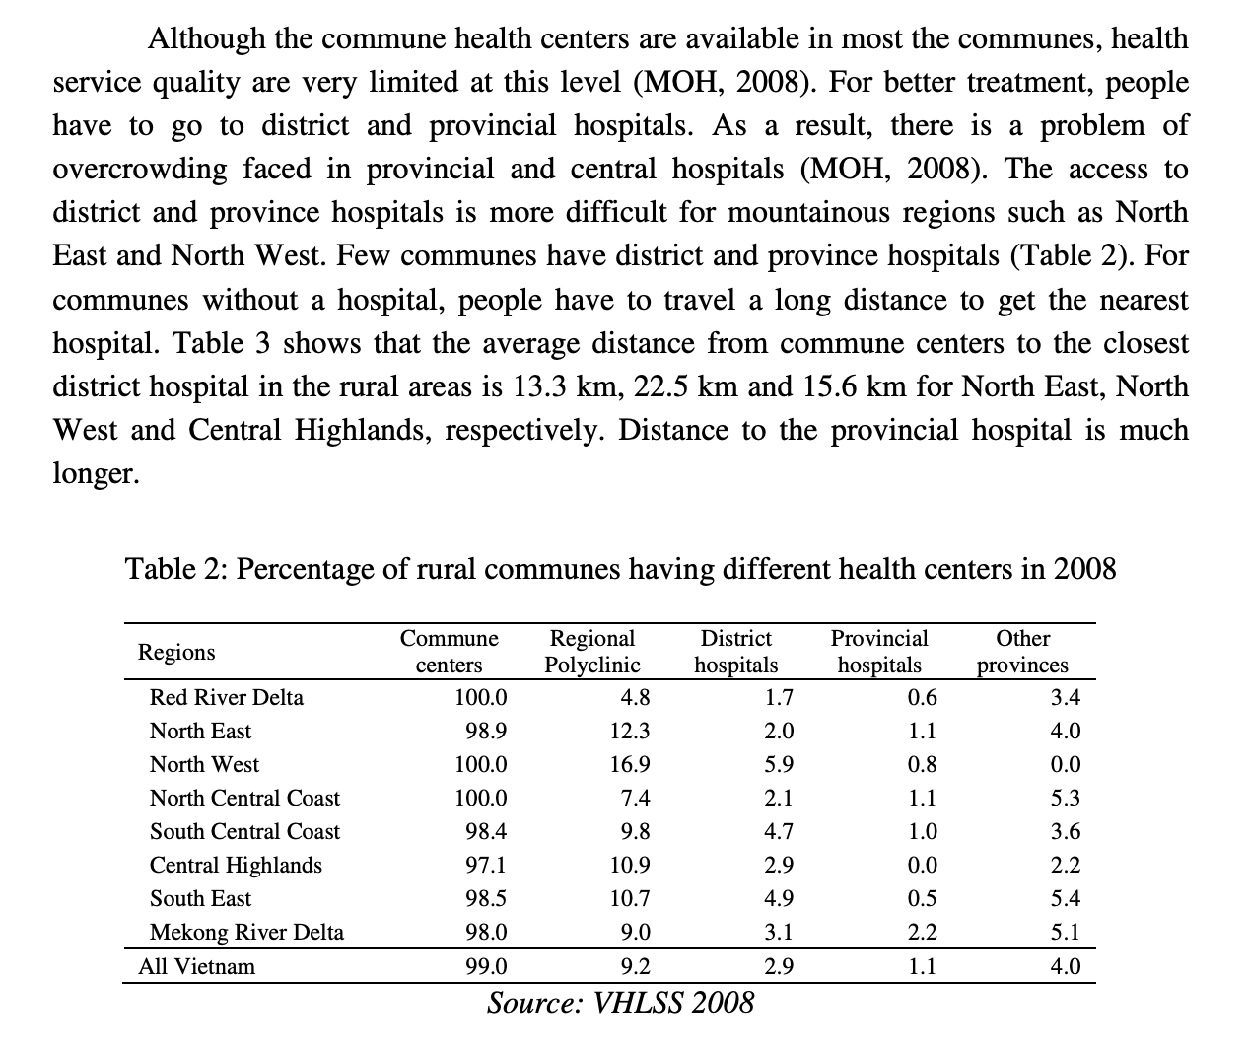

<https://core.ac.uk/download/pdf/211600611.pdf>

# Additional analyses

## Frequency and cumulative frequency of patients by straight line distance

1. Use the R script below
2. Remove outliers
3. Plot the eCDF and hist() plots
4. Exploratory data analysis with skim()
5. Can use the skimr library

Data which can be loaded include

* Haversine distances
* Travel distance and time (network matrix)

# Section X: Basemaps and outlines

Basemaps from sources such as Google Maps, OpenStreetMaps and Bing without cost. Note however that only OpenStreetMaps basemaps are open sourced, whilst Google and Bing are both proprietary, and so the use and distribution of generated maps using their basemaps may be subject to copyright.

1. In the browser tab of qGIS, under ‘XYZ Tiles’, OpenStreetMap should be available as a default option (we will go through how to add the others in later) – Double click this and an OpenStreetMap basemap layer should be added to your layers tab

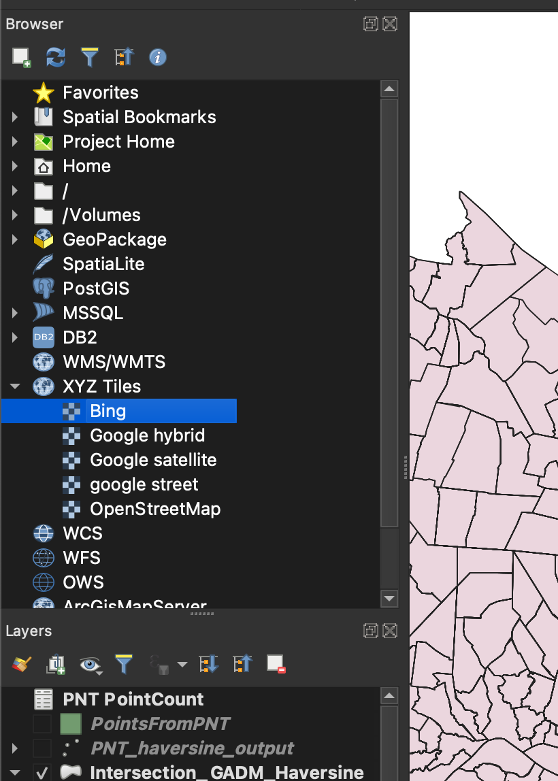

1. Ensure OpenStreetMap is at the last position of your layers (as in the image) otherwise it will overlap everything else and none of your previous work will be visible

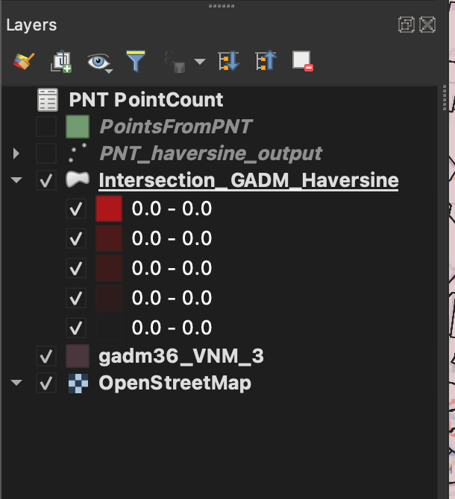

1. If you still have the GADM map from the original import, you can turn it into an outline over the map by right click -> Properties -> Symbology -> Opacity and turning the opacity lower such that the base map is visible through the GADM geometries

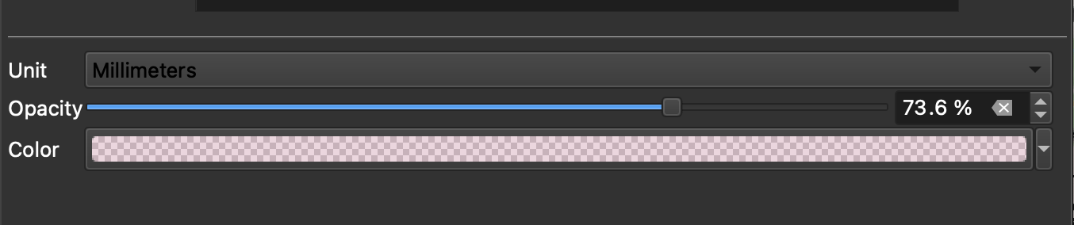

1. Your map should now look as follows

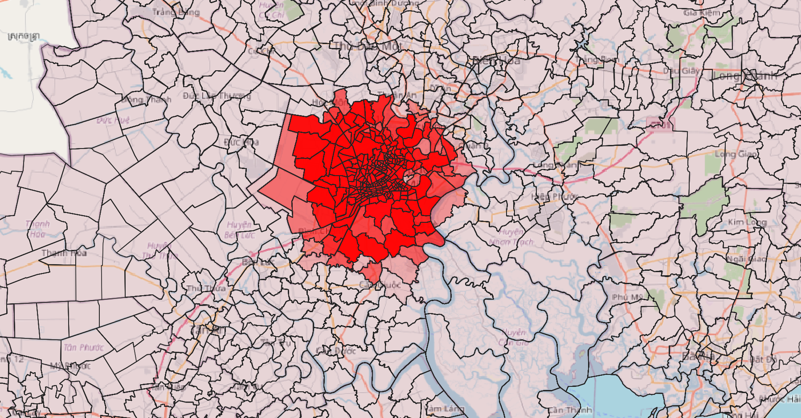

1. To remove the black lines, you can select the ‘Simple fill’ tab in the Symbology menu and change the stroke width and colour

To add additional basemaps,

1. right click the ‘XYZ tiles’ tab in the Browser and select ‘New connection’

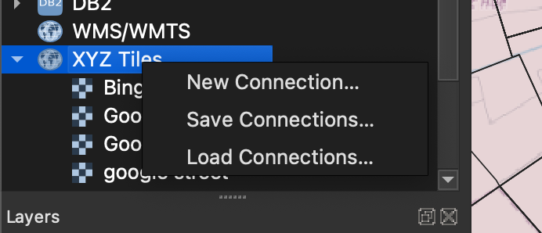

1. You will only need to fill out the ‘Name’ and the ‘URL’ sections of each new connection. The available connections you can use are as follows:

|  |  |  |
| --- | --- | --- |
| **Source** | Name | URL |
| **Bing Maps Satellite** | BingSatellite | ﻿[http://ecn.t3.tiles.virtualearth.net/tiles/a{q}.jpeg?g=1](http://ecn.t3.tiles.virtualearth.net/tiles/a%7bq%7d.jpeg?g=1) |
| **Google Maps Hybrid View** | GoogleHybrid | ﻿[http://mt1.google.com/vt/lyrs=y&x={x}&y={y}&z={z}](http://mt1.google.com/vt/lyrs=y&x=%7bx%7d&y=%7by%7d&z=%7bz%7d) |
| **Google Maps Satellite View** | GoogleSatellite | ﻿[http://mt1.google.com/vt/lyrs=s&x={x}&y={y}&z={z}](http://mt1.google.com/vt/lyrs=s&x=%7bx%7d&y=%7by%7d&z=%7bz%7d) |
| **Google Maps Street View** | GoogleStreet | ﻿http://mt1.google.com/vt/lyrs=m&x={x}&y={y}&z={z} |

1. To apply these basemaps, double click on the option in the Browser list and follow the instructions as above

# Section X: Exporting maps

The qGIS training manual has an excellent explanation of ways to export maps

<https://docs.qgis.org/3.16/en/docs/training_manual/map_composer/index.html>

This section will simply go over steps to make a basic functional map

1. Project -> Layout Manager
2. New from template -> Empty Layout -> Create
   1. Add a name for your map – e.g. PNT Haversine
3. The print layout menu should open

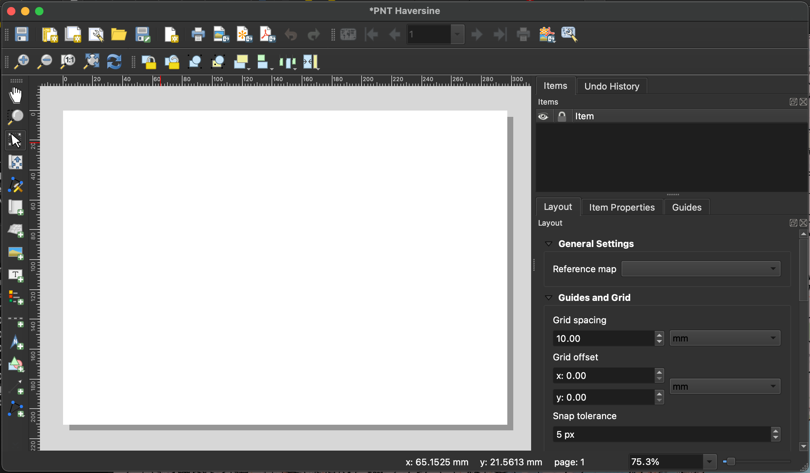

1. Make sure the item properties (Right hand side) are set to A4

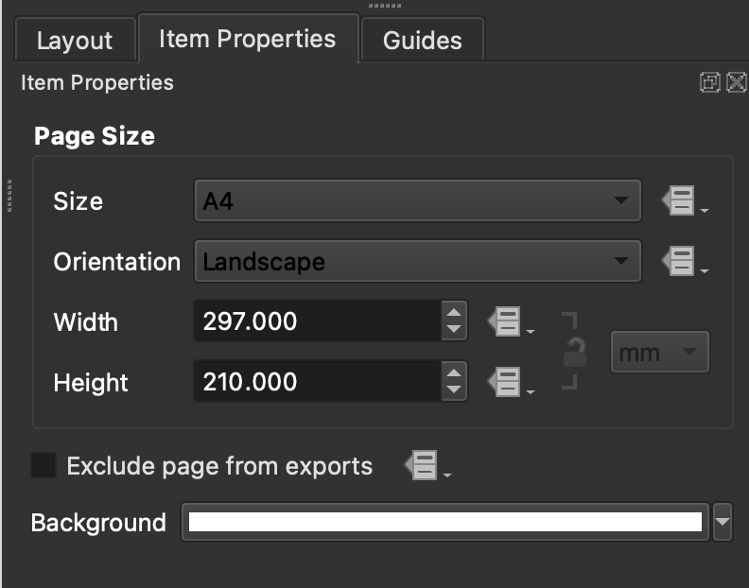

1. Click ‘Add new map’ on the toolbar on the left and drag an area for the map on the blank space

